|  |  |
| --- | --- |
|  | **MATHEMATICS:SPECIALIST 3 & 4**  **SEMESTER 2 2019**  **TEST 4**  **Calculator Free** |
|  |  |

Reading Time: 2 minutes Time Allowed: 30 minutes

Total Marks: 26

Question 1 (4 marks)

The curve defined by $y=3\cos\left(\begin{matrix}πx \\ \overline{ 16 }\end{matrix}\right)$, where $0≤x≤4$, is shown below.

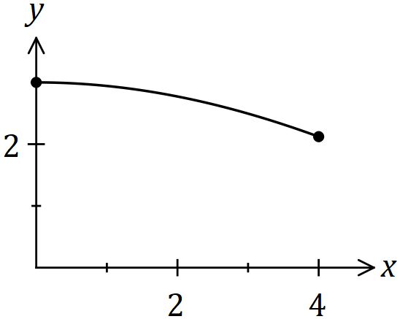

Determine the volume of the solid generated when the area bounded by the $x$ axis and the curve is rotated $360°$ about the $x$ axis between $x=0$ and $x=4$.

|  |
| --- |
| **Solution** |
| $$V=π\int_{0}^{4}{y^{2}}dx \\ =9π\int_{0}^{4}{\cos^{2}\left(\frac{πx}{16}\right)dx} \\ =\frac{9π}{2}\int_{0}^{4}{\left(1+\cos\left(\frac{πx}{8}\right)\right)}dx \\ =\frac{9π}{2}{\left[x+\frac{8}{π}\sin\left(\frac{πx}{8}\right)\right]}_{0}^{4} \\ =\frac{9π}{2}\left(\left[4+\frac{8}{π}\right]-\left[0+0\right]\right) \\ =18π+36 \text{cubic units}$$ |
| **Specific behaviours** |
| ✓ writes integral  ✓ re-writes integral using double angle identity  ✓ integrates  ✓ substitutes both bounds and simplifies |

Question 2 (5 marks)

Part of the graph of $y=1+\begin{matrix}4 \\ \overline{x(x-5)}\end{matrix}$ is shown below.

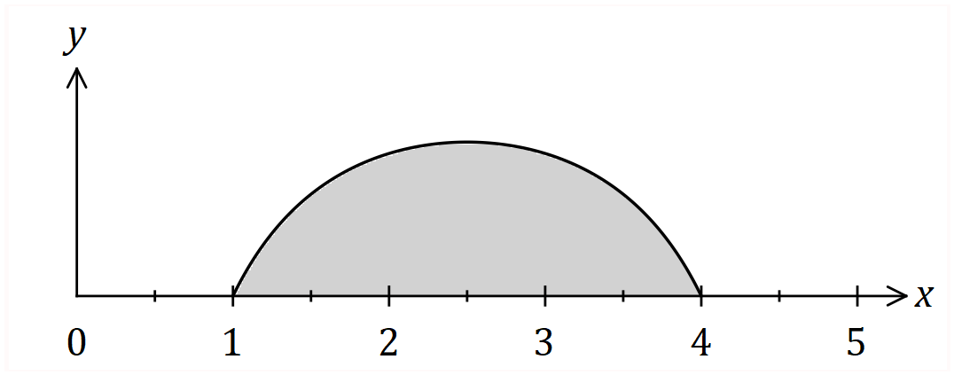

Determine the shaded area, bounded by the curve and the $x$-axis.

|  |
| --- |
| **Solution** |
|  |
| **Specific behaviours** |
| ✓ integral, recognising need for partial fractions  ✓ obtains partial fractions  ✓ integrates  ✓ substitutes limits of integration  ✓ simplifies until just one logarithm remains |

Question 3 (5 marks)



**Question 4(a) (4 marks)**

|  |  |
| --- | --- |
| Solution | |
| Since    it follows that | |
| Mathematical behaviours | Marks |
| * identifies correct double angle formula to use * simplifies the integral to requiring the anti-derivative of * integrates correctly * evaluates the indefinite integral at the end points | 1  1  1  1 |

**Question 4(b) (4 marks)**

|  |  |
| --- | --- |
| Solution | |
| If we put    then we find that | |
| Mathematical behaviours | Marks |
| * calculates  correctly * substitutes into integral changing the limits appropriately * integrates the expression correctly * substitutes the boundary values and simplifies to a suitable form | 1  1  1  1 |

**Question 4(c) (4 marks)**

|  |  |
| --- | --- |
| Solution | |
| If we put  then  and the integral    Hence if the integral equals $\frac{1}{2019}$ we conclude that *n* = 2018 | |
| Mathematical behaviours | Marks |
| identifies that   * identifies the most appropriate substitution * evaluates the integral correctly and thereby * deduces the correct value of | 1  1  1  1 |



Question 6 (6 marks)



Question 7 (4 marks)

|  |  |
| --- | --- |
| Solution | |
| If we write  Equating the coefficients gives  and  Hence | |
| Mathematical behaviours | Marks |
| * writes down the appropriate form of the partial fractions * compares coefficients to deduce the constants  and * integrates correctly * deduces the required result | 1  1  1  1 |

Question 8 (5 marks)

The region $R$ enclosed by the curves $y^{2}=kx$ and $x^{2}=27ky$, has an area of $1156$ square units.

Determine the value of the positive constant $k$.

|  |
| --- |
| **CAS solution** |
|  |

|  |
| --- |
| **Solution** |
| Intersect at $(0, 0)$ and $(9k, 3k)$ (CAS) $$A=\int_{0}^{9k}{\left(\sqrt{k}\sqrt{x}\right)-\left(\frac{x^{2}}{27k}\right)}dx \\ =9k^{2}$$ $$9k^{2}=1014⇒k=\frac{34}{3}=11.\overline{3}$$ |
| **Specific behaviours** |
| ✓ sketches curves  ✓ identifies points of intersection  ✓ correctly formed integral  ✓ evaluates integral in terms of $k$ ✓ solves for $k$ |